**Testing Protocol**

The purpose of the testing protocol is to see if the desired range of motion is achieved with the rotation-rotation-rotation joint configuration design within the specified requirements.

**Max range/volume**

This test is to determine the amount of “reach” provided by the design.

Assumptions: device is “virtually” fixed to femur

1. Choose a reference point to measure from. (Point on bone mount or center of femur, etc…)
2. Record the allowable range in x, y, and z axis.

* Is the workable area sufficient?
* Are there any areas where the tool cannot be oriented?
* Note: max range should be before lateral deflection occurs (when link1 is almost 90 degrees)

**Implant Shape**

This test is to determine if the device is able to orient and maneuver in the implant shape.

Assumptions: device is fixed to (perhaps pre-cut?) femur.

1. While keep the “cutting bit” perpendicular to the cutting surface, trace these shapes with various stroke directions

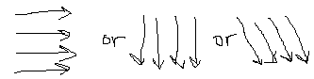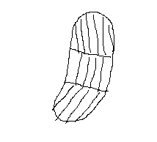

1. Repeat for the other condyle with current mount point if possible.

* Are there any issues with maneuverability?
* Are there any inaccessible regions?

**Angular error/surface penetration**

This test is to determine how much “bending” there is when the device is rigid.

Assumptions: device has all points fixed in a position where the hard constraint is active and max error could occur

1. Apply a reasonable and uniform force (???) into the “surface” and record any error observed.

* Error should be less than 3 degrees or less than 1mm of surface penetration